**Test Case 1. Reset the test data**

Issue: I have entered the Bearer Token, but the request is still returning an authentication error (401).

**Test Case 2. Buy a quantity of each fuel**

Issue: The ID and Quantity don’t work. It prompts the failed result "AssertionError: expected response to have status code 200 but got 404".

**Test Case 3. Verify that each order from the previous step is returned in the /orders list with the expected details**

Issue: Unable to verify. Prompts error 500, server-side issue, something went wrong while the server was processing the request.

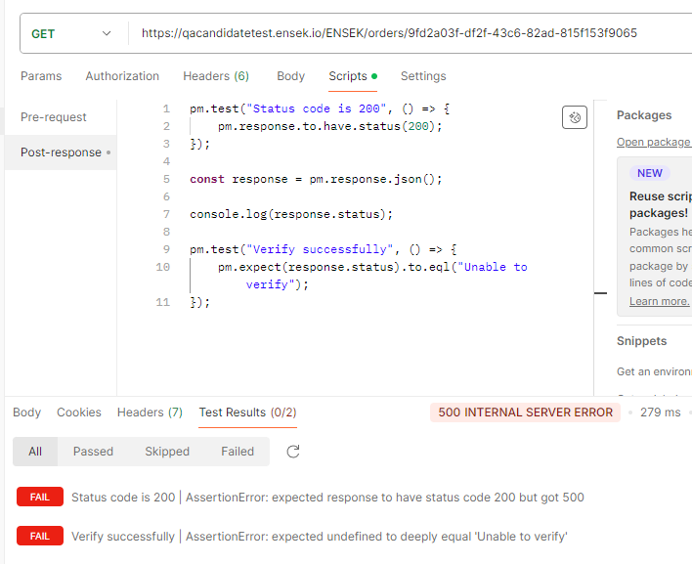

**Test Case 4. Confirm how many orders were created before the current date**

No issue was found.

**Test Case 5: List out all Energy**

No issue was found.

**Test Case 6: buy 1000000 oil, exceed max qty (Boundary Case)**

Issue: AssertionError: expected response to have status code 400 but got 404

**Test Case 7: Buy energy ID 999 for 1 unit, Invalid Energy Purchase (Negative Case)**

No issue was found.